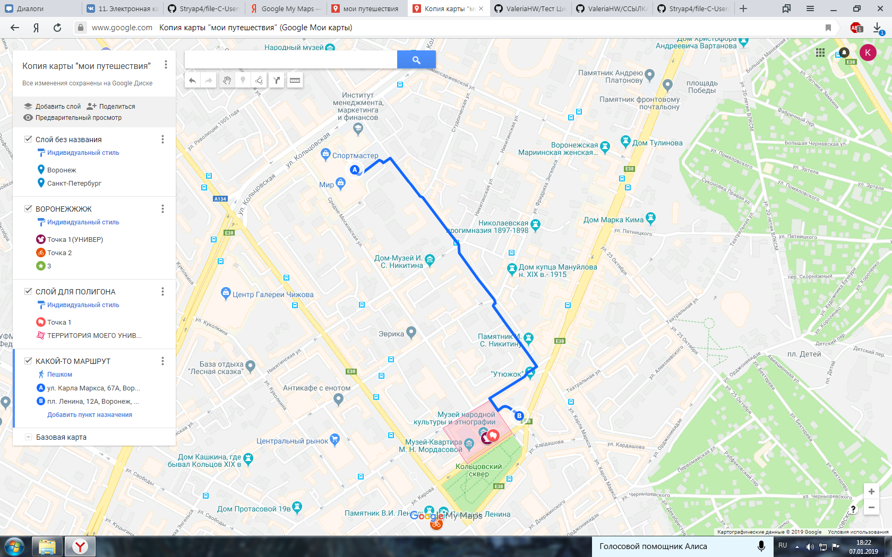

<https://www.google.com/maps/d/edit?mid=14Zq_P4HK-jpuV84t3hqe6FWArQDbkMvL&ll=51.66654468550725%2C39.200604999999996&z=16>